Vilniaus g.159, LT-18177, Švenčionių raj., Pabradė
Mob.tel.:+37065798006; +37060999043
El.paštas:info@vdpack.lt
Tinklalapis: www.vdpack.lt

DECLARATION OF CONFORMITY/SPECIFICATION

Gamintojas/ tiekėjas | UAB‘‘VD PACK‘‘
Deklaruojama medžiaga ar gaminys | LDPE garbage bags blue: 60L 10pcs; 30 mk 60x75 cm  LDPE garbage bags yellow 60L, 10 pcs; 30 mk, 60x75 cm
Deklaracijos pateikimo data | 2026-06-15
This material/product complies with the applicable requirements of:
• Directive 94/62/EC on packaging and packaging waste, as amended;
• Regulation (EU) 2025/40 on packaging and packaging waste (PPWR), where applicable;
• Harmonised European Standards EN 13427, EN 13428, EN 13429 and EN 13430 relating to packaging and packaging waste.
The company declares that Lead (Pb), Cadmium (Cd), Mercury (Hg) and Hexavalent Chromium (Cr VI) are not intentionally added during the manufacturing process. The sum of the concentrations of these heavy metals does not exceed 100 mg/kg (100 ppm), in accordance with the requirements of Directive 94/62/EC and applicable European packaging legislation.

Analysis | Research |  | Unit of measurement
 | Method identifier | Results ±U
Lead | LST CR 13695-1:2002 (N) | 1,25 |  | mg/kg
Cadmium | LST CR 13695-1:2002 (N) | 0,125 |  | mg/kg
Mercury | LST CR 13695-1:2002 (N) | 0,0625 |  | mg/kg
Chrome | LST CR 13695-1:2002 (N) | 1,65 |  | mg/kg
Chemical test protocol: Nr. CH1833/2025 2025 04 15

The Company declares that the bags are recyclable and are manufactured in accordance with the requirements of the Company's Standard EST 301534686-01:2026.
The dimensions of plastic films and bags, as well as the permissible dimensional tolerances, comply with the requirements specified in the Company's Standard EST 301534686-01:2026 and are defined in the applicable technical documentation and/or customer specifications.
Unless otherwise specified, dimensional tolerances are applied in accordance with LST EN ISO 2768-1, tolerance class "v" (very coarse), or as agreed with the Customer.
The packaging is designed to support recycling in accordance with applicable European packaging legislation, including Regulation (EU) 2025/40 on packaging and packaging waste (PPWR), where applicable.
The film thickness tolerance is ensured by assembly, the factory tolerance of which is ±2 ɱk.
Storage period: 10 years.
Kokybės vadovė  Erika Oleiničak  erika@vdpack.lt | 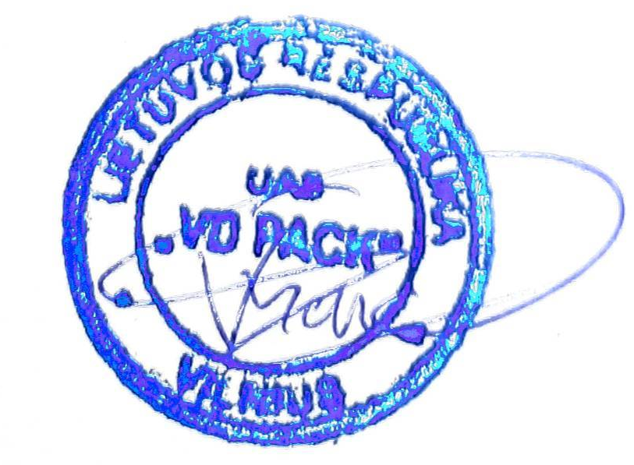 | Data:  2026 06 15

